**Shopify: My Live Cart App**   
  
Introduction  
  
Version Compatibility

Shopify Online Store 2.0  
  
Installation

To Install the MyLiveCart App follow these steps -

1. **Log in to Shopify:** Access your Shopify account and log in to your admin panel.
2. **Visit Shopify App Store:** Navigate to the **Apps** section in your Shopify admin.
3. **Search for MyLiveCart:** Use the search bar to find the MyLiveCart app in the Shopify App Store.
4. **Install the App:** Click on the MyLiveCart app, then select **Add app** to install it on your store.
5. **Configure and Activate:** Follow the prompts to configure the app based on your preferences.
6. **Verify Integration:** Check your Shopify store to ensure the MyLiveCart features are integrated and working smoothly.

Certainly! After installing MyLiveCart on your Shopify store, integrate event analytics code by adding these snippets to your product and cart page templates:

1. **Product Page**: In the Custom Liquid section of your product page template, paste:  
   {% render "cb-main-product-snip" %}

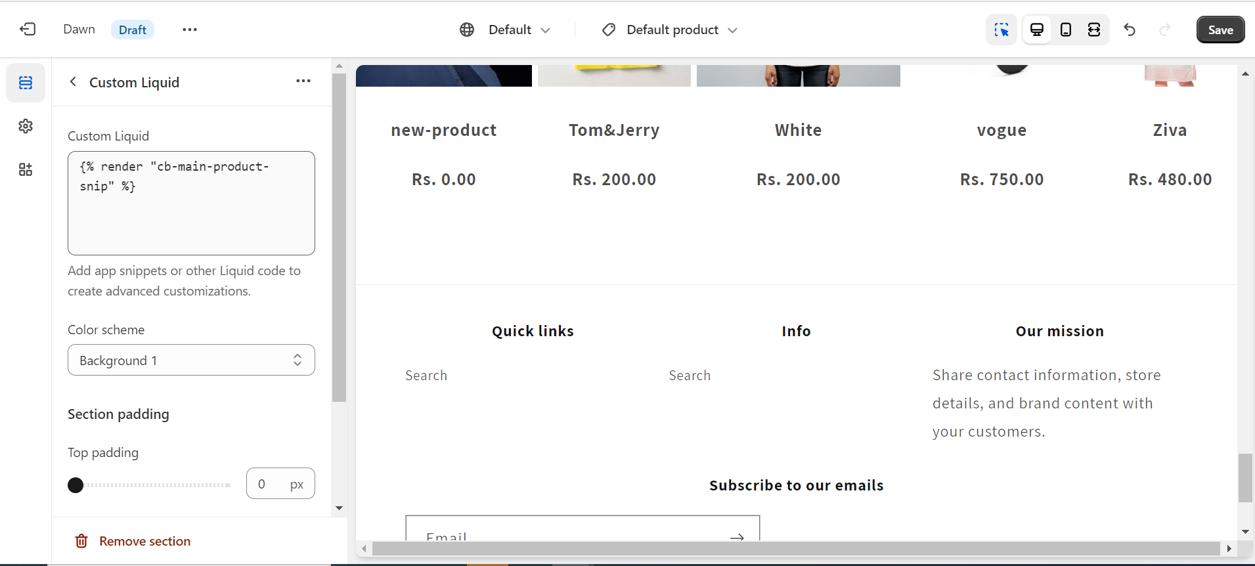

1. **Cart Page**: In the Custom Liquid section of your cart page template, paste:  
   {% render "cb-main-cart-snip" %}

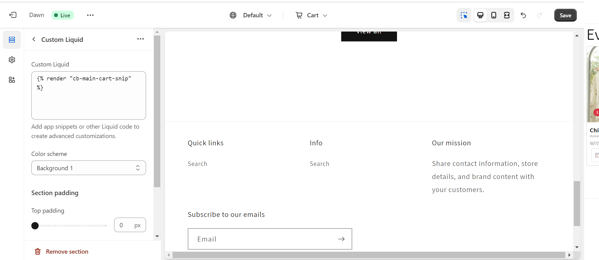

These snippets, placed within the Custom Liquid section, enable MyLiveCart's event analytics, displaying insights directly on your web app. Ensure the snippets are correctly placed for accurate tracking and analysis.

Your MyLiveCart app is now installed and ready to enhance your Shopify store functionalities.

How to Connect with MyLiveCart WebApp?

Step 1: Access your Shopify Admin Dashboard and navigate to the Authentication Tab.

Step 2: Ensure your Store URL and Access Token values are not empty.

Step 3: Initiate the connection by clicking the "Connect to MyLiveCart" button, establishing a seamless link to the MyLiveCart WebApp.

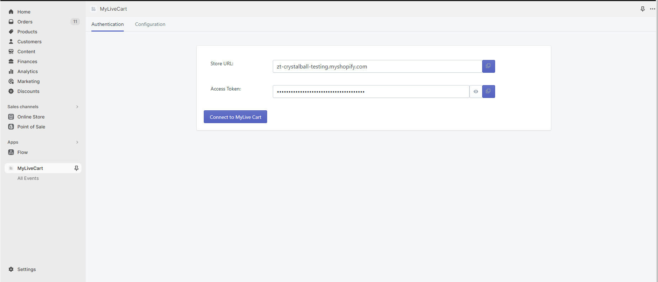

Step 4: Upon logging in or registering on the MyLiveCart WebApp, you'll receive an exclusive authentication key. This key can be automatically configured or manually adjusted to suit your specific requirements.

Step 5: With the authentication key in place, you gain full access to all the advanced features and functionalities offered by MyLiveCart within your Shopify store.

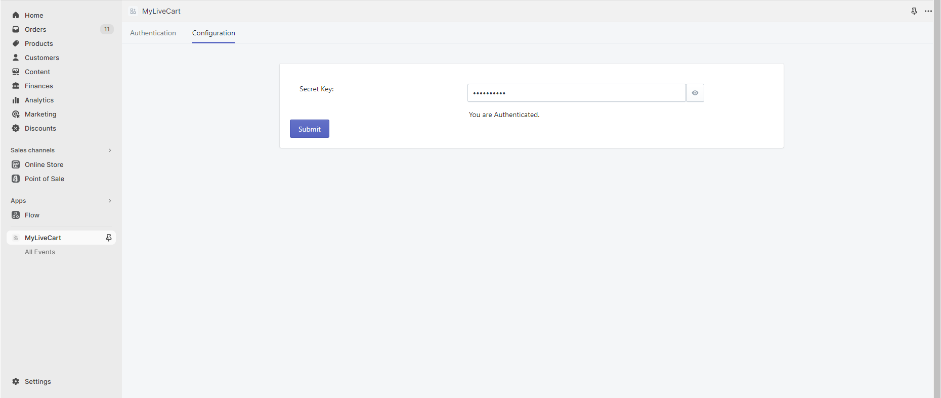

By following these steps, your Shopify store will be seamlessly connected to the MyLiveCart WebApp, allowing you to make the most out of its features and capabilities.  
  
How to create an Event

You have the flexibility to create events using either the MyLiveCart WebApp or your Shopify Store Admin directly through the MyLiveCart app.

Here you can find the steps on how to create events through App:  
  
Step 1: Access your Shopify Store Admin.

Step 2: Go to MyLiveCart App All Events tab and click on "Create Event". This action will direct you to the Event Creation page.

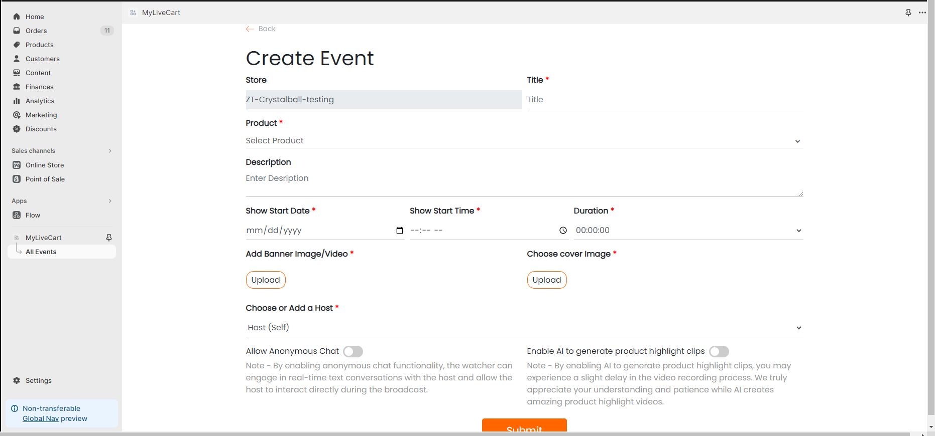

Step 3: Provide all the necessary event details in the form and then submit your input.

Step 4: Upon successful creation, you'll be redirected to the All Events Page. In case of errors, appropriate error messages will be displayed on the same page for correction.

By following these steps within your Shopify store, you can seamlessly create and manage events using the MyLiveCart app, enhancing your store's functionality and engaging your customers effectively.

Where can users access events as regular users?  
On your Shopify store, users can access events through a dedicated 'Events List' page,  
You can also assign Event List Page to Menu:

Shopify Admin: Go to Online Store > Navigation.

Add Page: Add your Event List page under "Page".

Save: Click "Save menu" to apply.



Now, users can easily access events on the 'Events List' page from the store's menu.  
And navigate through live, upcoming, and completed events, and click on event cards for detailed information. This streamlined approach ensures that regular users can effortlessly stay informed about all the events your Shopify store has to offer, promoting engagement and participation.

Where can users find live events?

Users can swiftly access live events with just one click. Tapping on an event card on Events List page instantly redirects them to a dedicated individual event page, providing detailed information about that specific event.

